
Cruise ship system
Eagle of the ocean
Team Members
- Retaj Ali Ismael: 231005689
- Farah Hossam Saafan: 231005819
- Yassin Tamer Essam: 231006879
- Yasser Mohamed Hussein: 231014729

Supervised by
DR. Osama Hanafi
Introduction
Our cruise ship access system offers a multiple of benefits and unique features that set it apart from other systems, the system allows for efficient management of onboard activities, dining reservations, and room services. We choose to be organized to make it easy for the user to find everything, we also provide detailed information such as flight prices, room availability, activity schedules, as well as bills and fees. Our system offers ensuring the safety and privacy of all guests. With our system you can easily plan and book your entire cruise trip, making for an unforgettable and effortless experience for all.

Site visit report
1. What cuisine do we have in our cruise ship?
Our cruise ship offers a variety of cuisines including Italian, Asian, Egyptian and American, all prepared by our talented chefs.
2. How often are the rooms cleaned and maintained?
The rooms cleaned and maintained daily by the housekeeping staff.
3. What safety measures are in place to prevent accidents on a cruise ship?
Life boats, life jackets, and trained crew members, to prevent accidents and ensure the safety to passengers.

4. How does the cruise ship’s navigation system work?
Uses advanced technology, such as GPS and radar to determine the ship’s position and route.
5. What kind of data is stored in the system?
Passenger Information, reservations, and financial data.
6. How is the system secured?
Through password protection.
7. Is wifi available on the cruise ship?
Yes, the ship offers wifi packages for passengers to stay connected during their trip.
8. Is there a medical center on board in case of emergencies?
Yes, our cruise ship is required to have a medical center with trained medical staff and supplies available 24/7 in case of emergencies.
9. What types of activities are typically offered on a cruise ship?
Our cruise ship offers too many activities such as Casino, cinema, aquaparks, live shows and music concerts.
10. What are popular destinations for our cruise ships?
Our popular destinations are Hawaii, Canada, Alaska and Vietnam.
Problem statement
The proposed system aims to solve the issue of overcrowding and long wait times on cruise ships, which can lead to a negative experience for passengers. By implementing a more efficient, organized and innovative systems to manage the maintain cruise ships, it’s hoped that passengers will have a more enjoyable and stunning cruise experience. This system will also benefit the cruise company by improving customers satisfaction and potentially increasing revenue.
System objectives
The main objectives of a cruise ship system include providing a safe, enjoyable experience, and comfortable mode of transportation for passengers, to offer a variety of entertainment and activities on board, to provide high quality food and services, and maintain a high level of customers satisfaction to ensure repeat business and to efficiently manage the ships operations and crew, Finally a cruise ship system also aims to provide a positive and memorable experience for passengers, encouraging them to return for future trips and recommend the company to others.
System scope
Creating an Entity-Relationship Diagram (ERD) for a cruise ship involves identifying and defining the entities, their attributes, and the relationships between them. Here's a basic scope for an ERD of our cruise ship:
Entities: Activities
Attributes: Activities ID (primary key), Types, Cruise ship ID
Relationships: Cruise ship (M:1)
------------------
Entities: Bill
Attributes: Bill ID (primary key), Date, Name, Reservation ID, Employee ID, Customer ID, Amount
Relationships: Reservation (M:1), Customer (M:1), Employee (M:1)
--------------
Entities: Cruise ship
Attributes: Cruise ship ID (primary key), Destination, Cruise name
Relationships: Activities (1:M), Room (1:M), Manage (1:M)
----------------
Entities: Customer
Attributes: Customer ID (primary key), Customer Name, Customer Email, Customer Birthday, Phone number, Room ID, Trip
Relationships: Room (M:1), Bill (1:M)
-----------------
Entities: Department
Attributes: Department types, Manager ID, Department ID (primary key), Manger start date
Relationships: Employee_1 (1:1), Manage (1:M), Employee (1:M)
-----------------
Entities: Employee_1
Attributes: ID number (primary key), Department number, Name, Gender, Salary, Position, Address, Email, Phone number, Birthday date
Relationships: Department (1:1)
----------------
Entities: Flight price
Attributes: Flight ID (primary key), Date, Flight price, Room availability, Reservation ID, Trip
Relationships: Reservation (M:1)
----------------
Entities: Employee
Attributes: ID number (primary key), Name, Gender, Salary, Position, Department number, Address, Email
Relationships: Department (M:1), Bill (1:M)
----------------
Entities: Reservation
Attributes: Reservation ID (primary key), Reservation start date, Reservation end date
Relationships: Bill (1:M), Flight price (1:M)
-----------------
Entities: Room
Attributes: Room ID (primary key), Room type, Room number, Cruise ship ID
Relationships: Customer (1:M), Cruise ship (M:1)

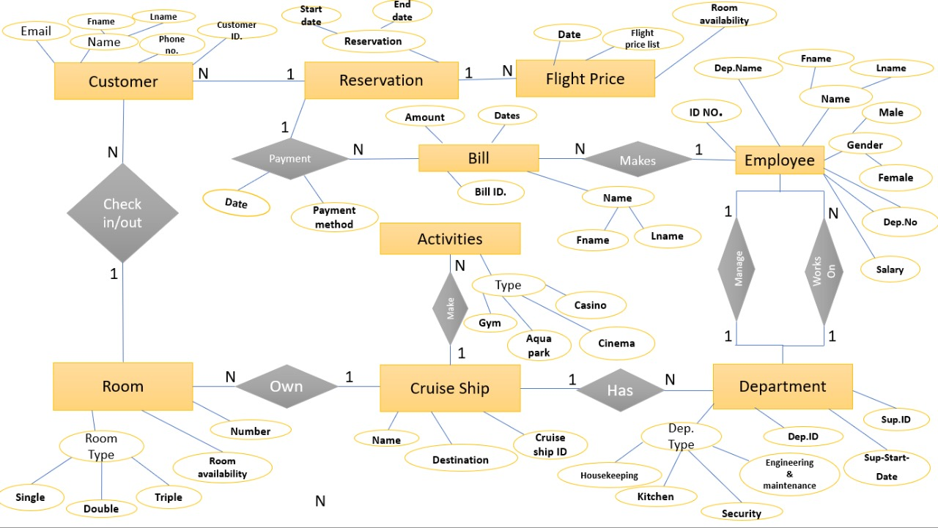
ERD

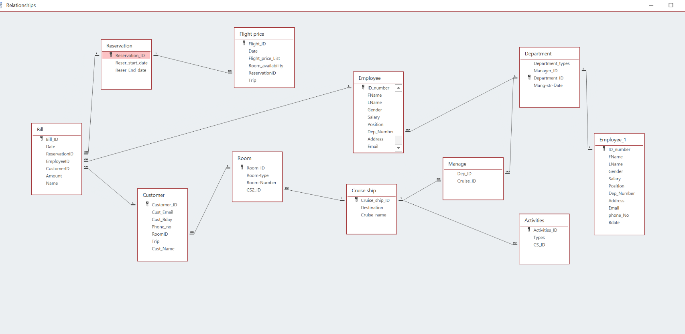
Relationships

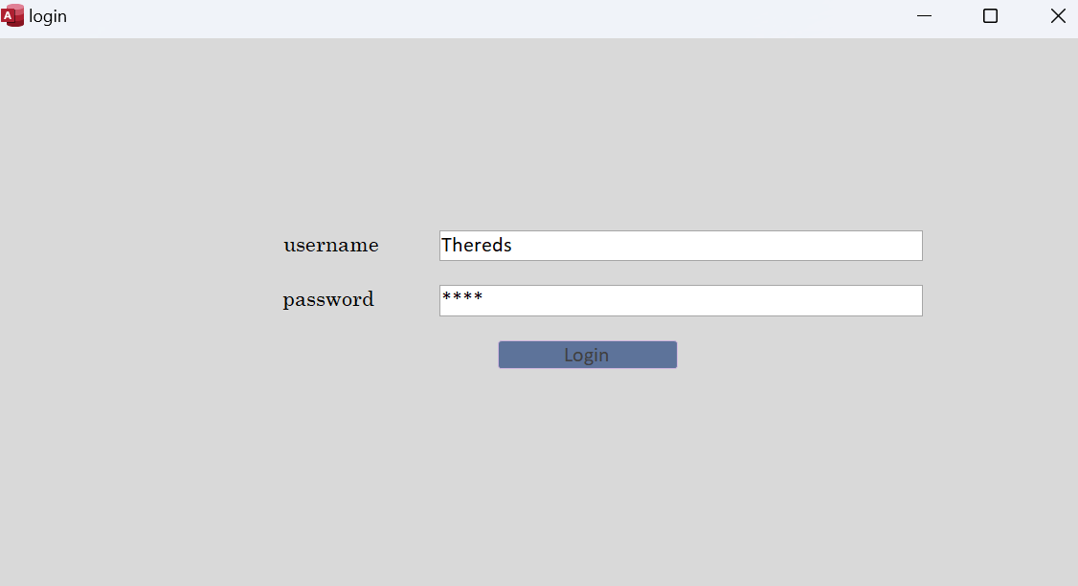
Login Form
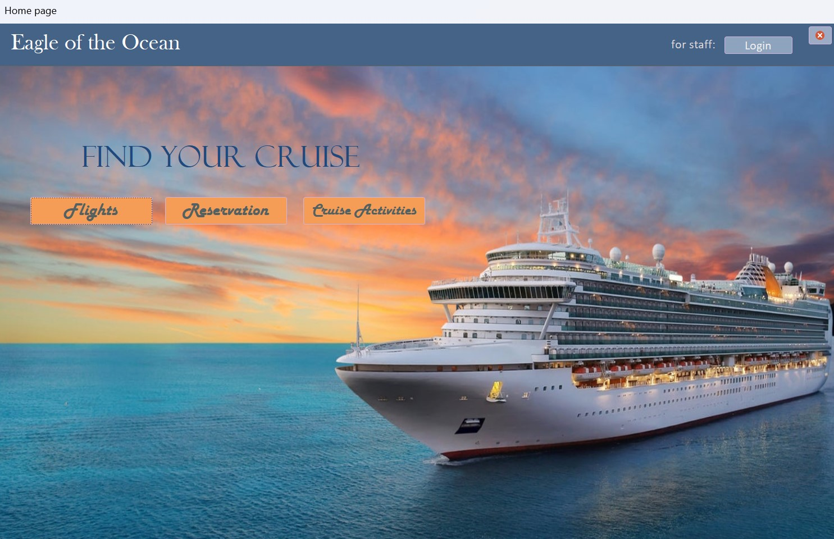
Forms
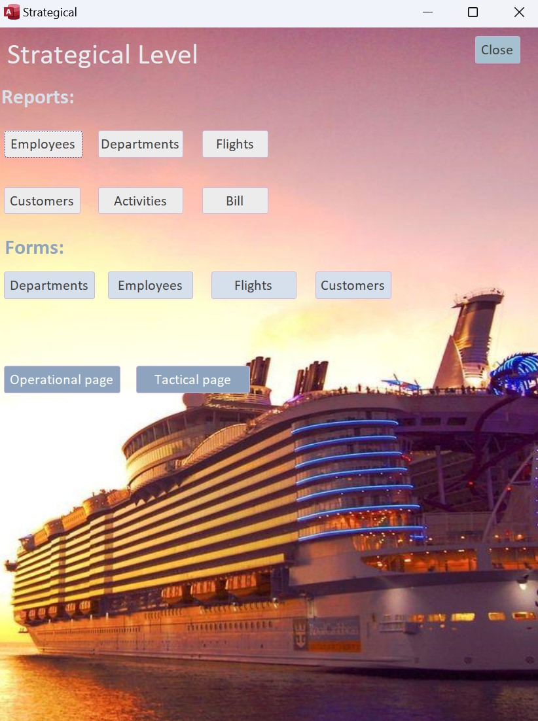
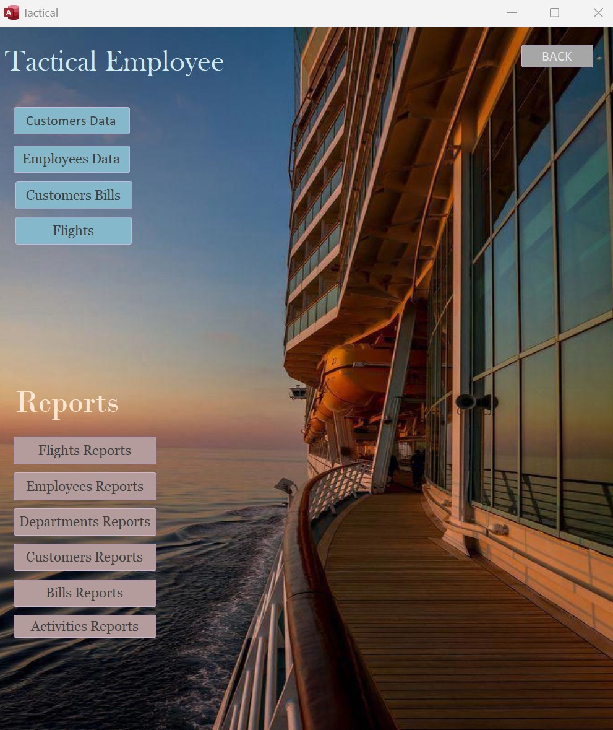
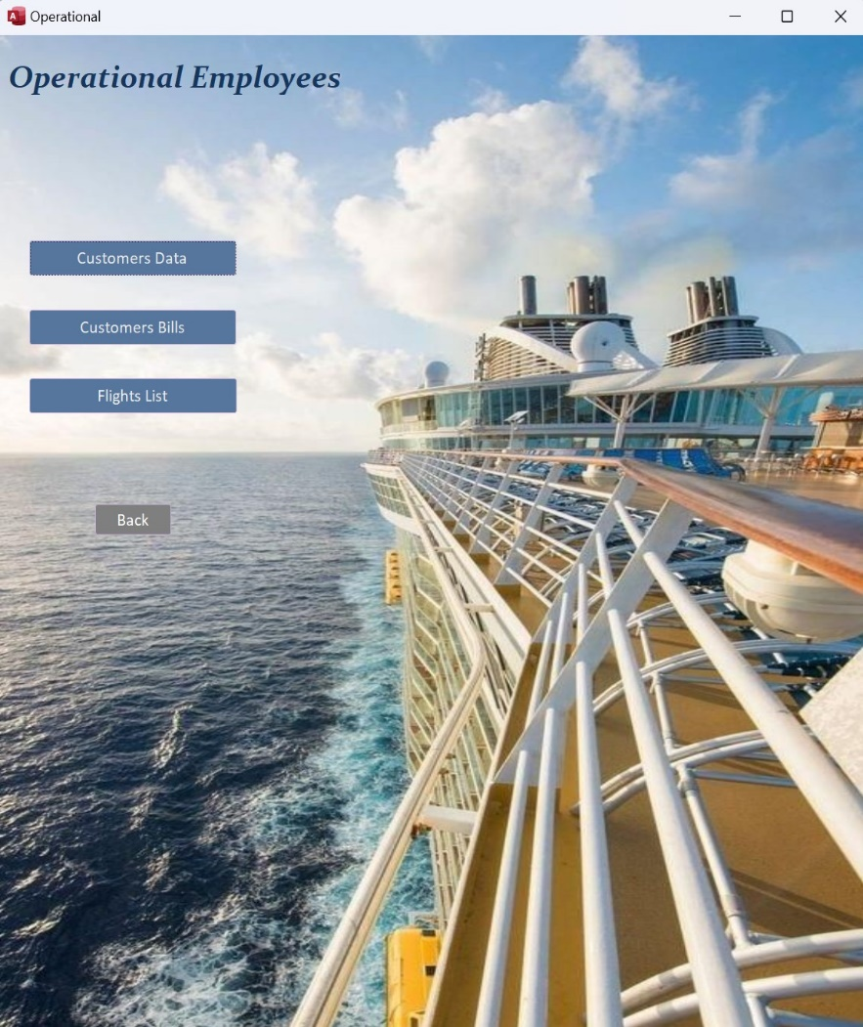

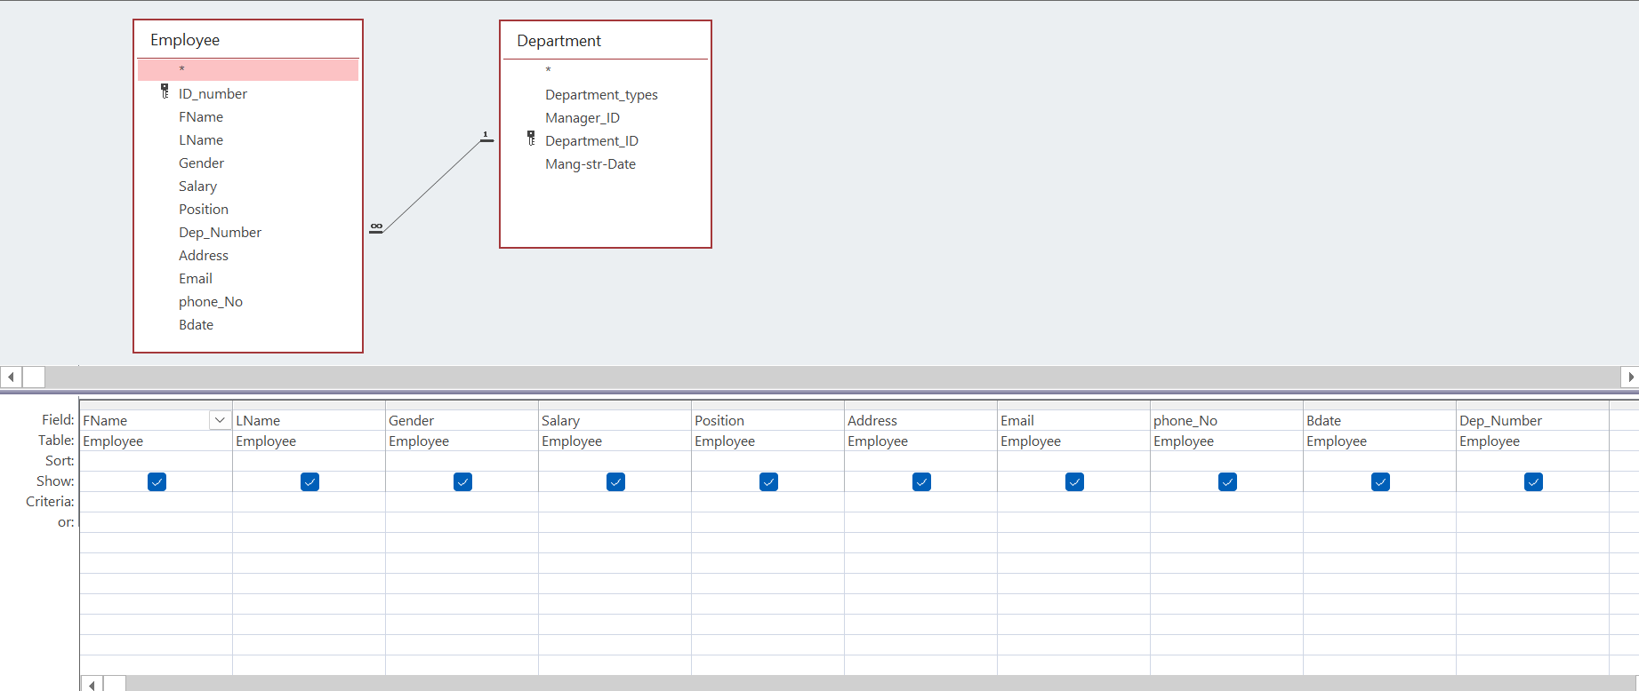
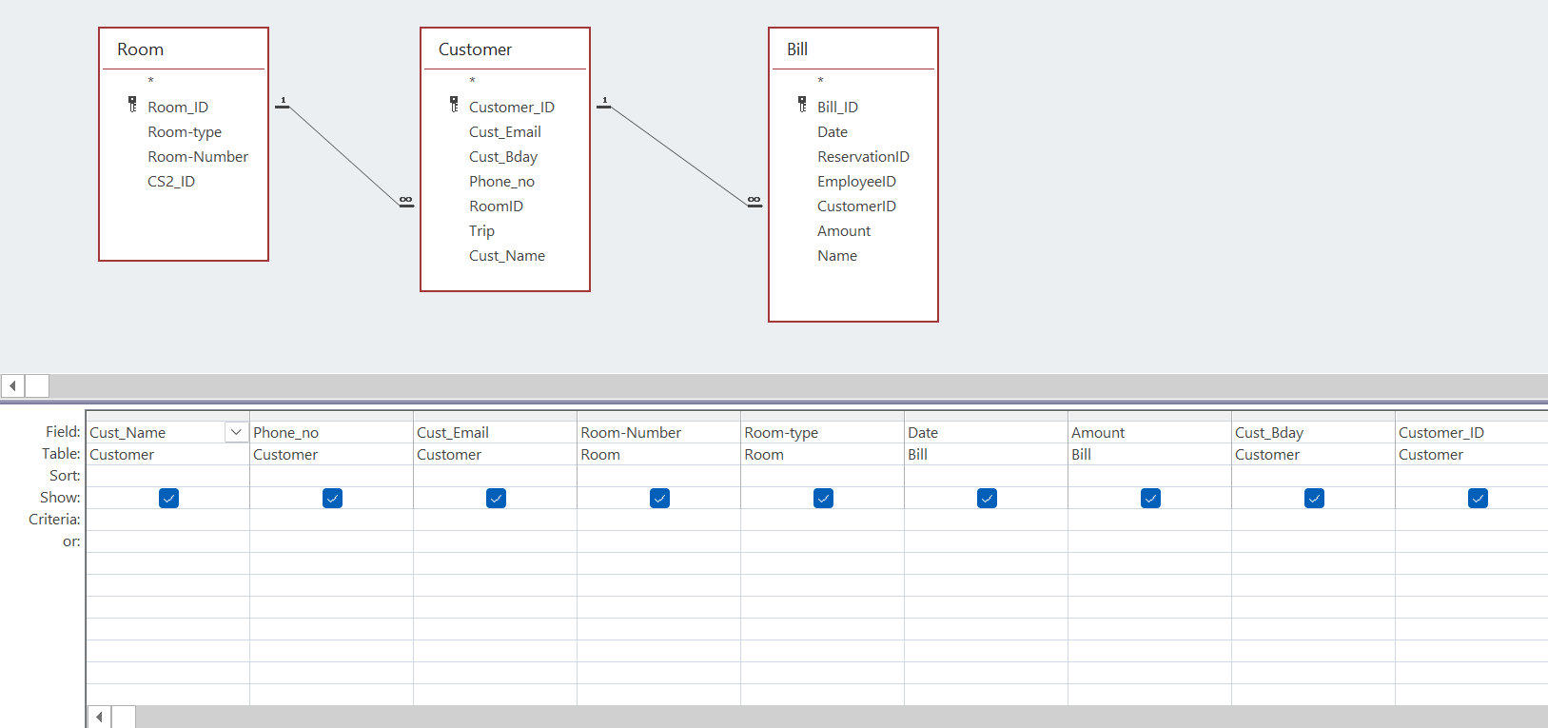
Queries

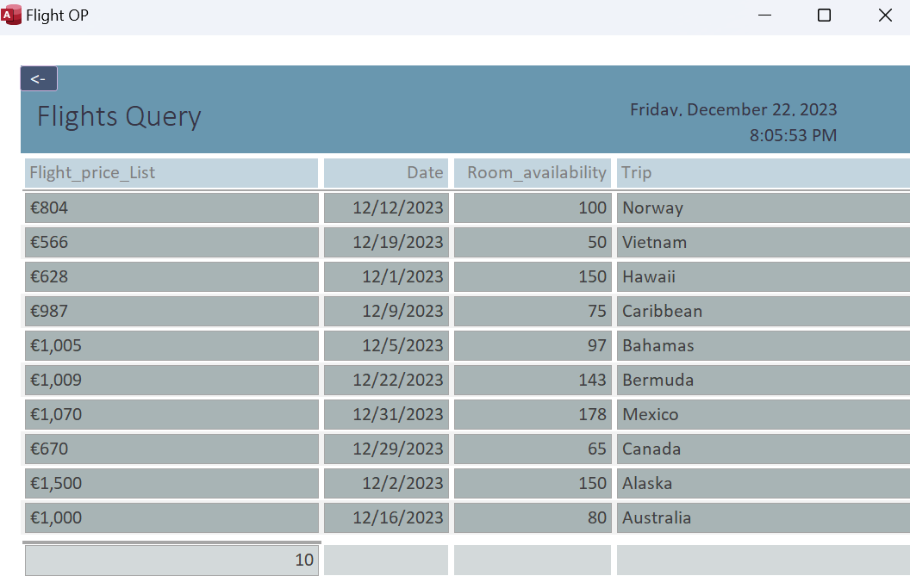
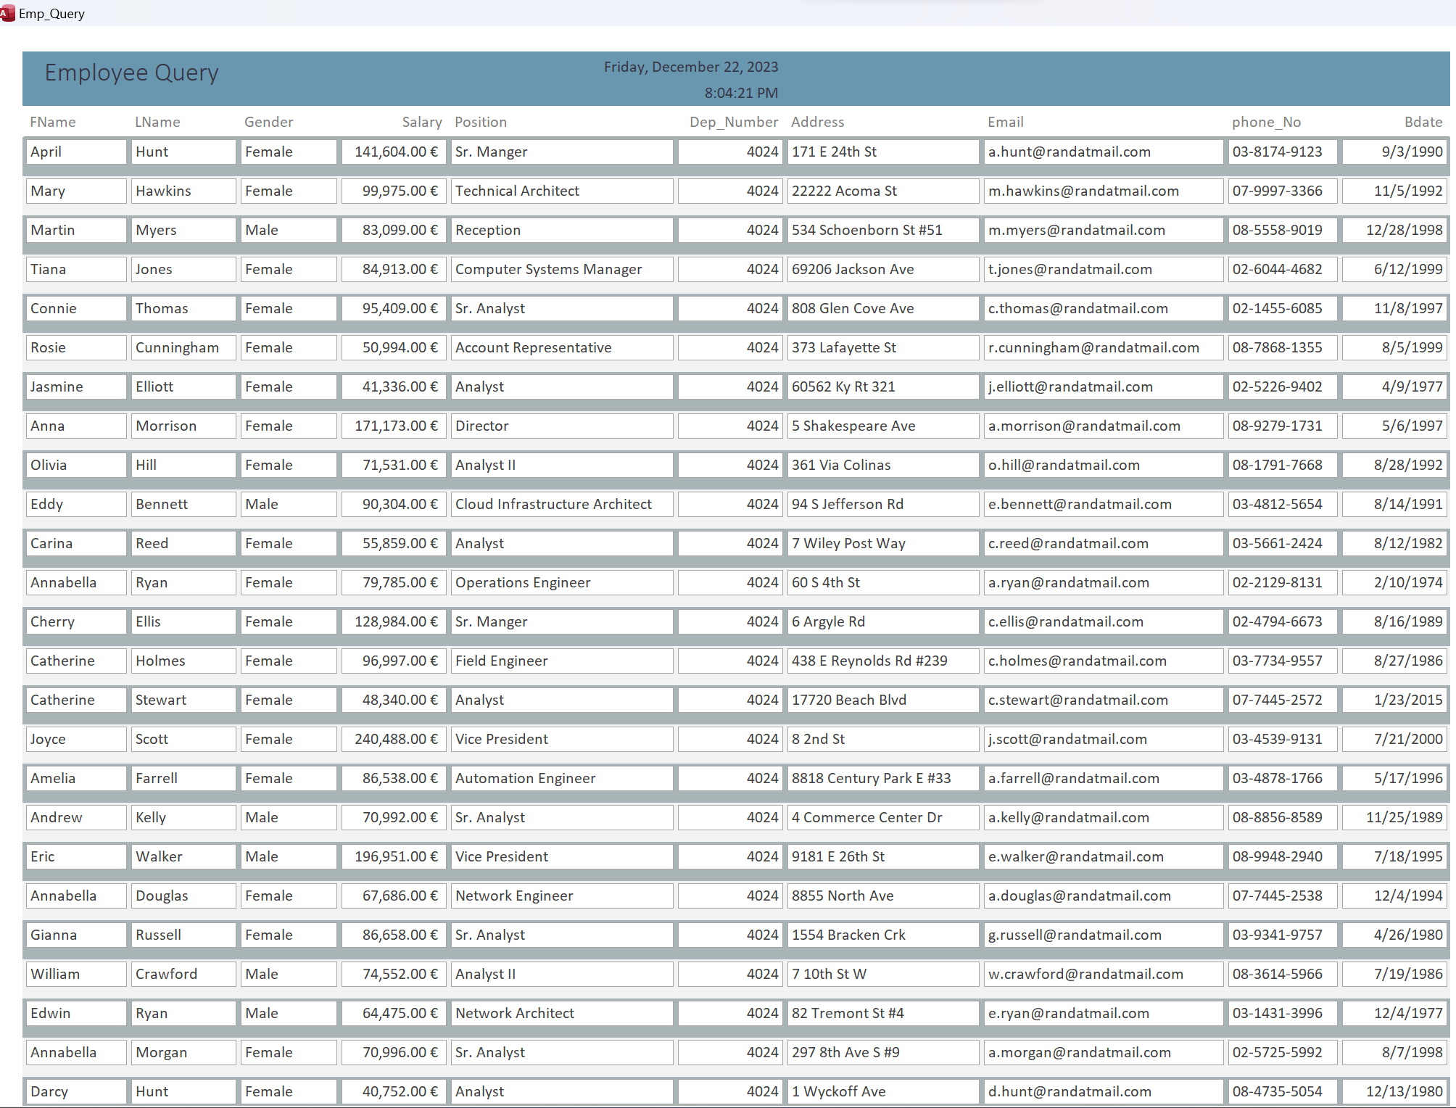
Reports
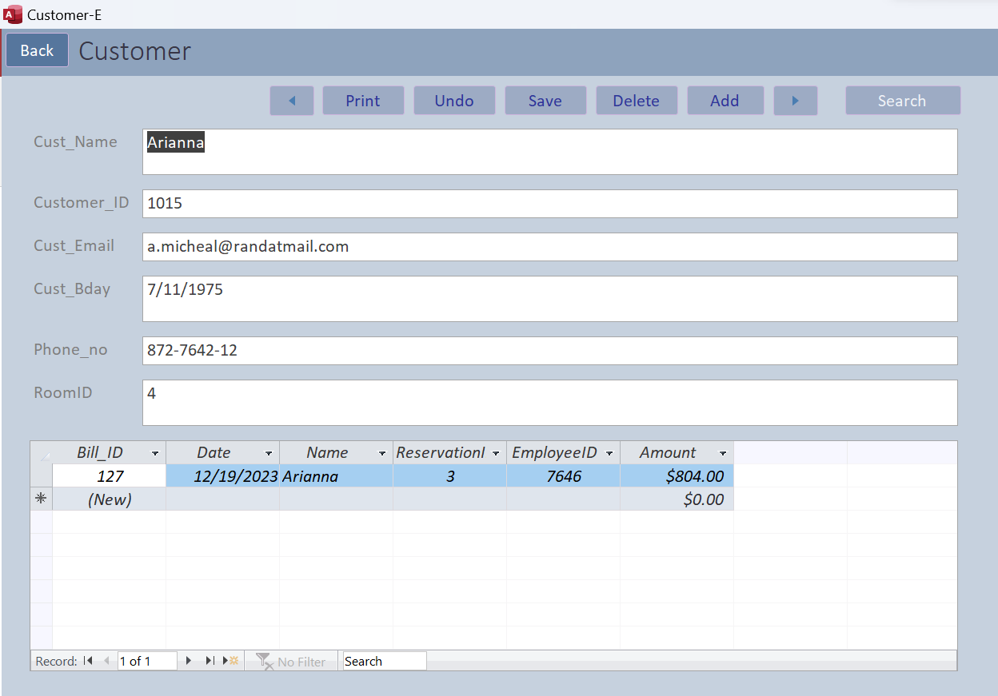
System Features

Customer-E form buttons:
- Back: to go to the previous page “operational page”.
- Previous button: to go to the previous row of customer data.
- Print button: to print the data of the customers.
- Undo button: to remove the data you wrote.
- Save button: to save the data of the customers after delete or add or edit anything in the data.
- Delete button: to delete a row of customer’s data.
- Add button: to add a new data for a new customer.
- Search button: to search for customer’s data.

